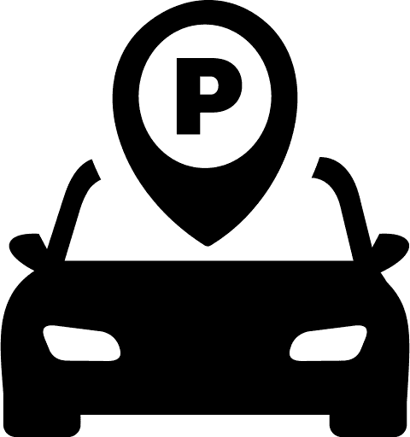
 | PARKING RECEIPT
Address
[Contact Number]
 | Ticket#: 0000000
 | Date: 00/00/00 | Time: 00:00 PM
 | Duration: [Hours] [Minutes]
 | PAID: $0
THANK YOU AND DRIVE SAFELY

